CASE FILE 03
Northbound Packs
Product line: backpacks
Northbound Packs designs backpacks out of an Evanston studio. Their one bag sells fine, but customers keep asking for 'the same bag, but...' and every request is different.
Your job: Build a lineup of three versions, one for each segment below. For every version, choose its features and set its price. Your goal is the most total profit across all three.
THE MARKET: THREE SEGMENTS
Northbound Packs surveyed people in the Chicago area. The survey split them into three groups. Read the profiles, then give each segment a name.
SEGMENT A  15,000 potential customers | SEGMENT B  6,000 potential customers | SEGMENT C  5,000 potential customers
- High school students, ages 14 to 18  - Carries a laptop, books, and gym clothes every day  - Parents usually pay and expect it to last  “My bag has to survive four years and a locker.” | - College students and young adults who travel  - Flies 3 or more times a year, always carry-on only  - Packs for a week out of one bag  “I refuse to pay a checked bag fee.” | - Ages 25 to 45, commutes downtown by train  - Carries a work laptop every day  - Wants a bag that looks right in a meeting  “It needs to look good in a meeting and survive the train.”
Our name for them: | Our name for them: | Our name for them:
PRODUCT BASICS
Base cost of every version | $11 per bag, before any features are added
Price options | $30 $45 $65 $90 $120 $160 (each version must use one of these prices)
WARM-UP: READ THE DATA FIRST
1. Which segment has the most must-have features (60% or higher)? How many does it have?

2. What is the most expensive feature on the menu? Which segment, if any, says it is a must-have?

3. What is the lowest price at which fewer than half of Segment B would buy?

4. If Northbound Packs sold a version with a Fit of 100% to Segment A at $45, how many people would buy it?

SURVEY RESULTS: WHAT EACH SEGMENT REQUIRES
Question asked: “Which of these would a backpack need to have before you would buy it?”
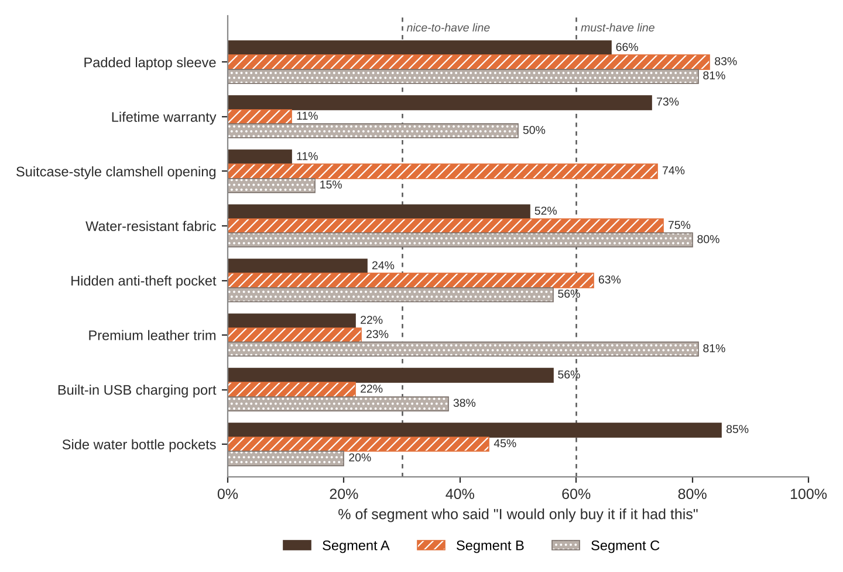
FEATURE MENU
Every feature you add raises your cost per bag. Add a feature to any version you want.
Feature | What it is | Cost to add
Padded laptop sleeve | Fits up to a 16-inch laptop | $4
Lifetime warranty | Free repair or replacement, forever | $8
Suitcase-style clamshell opening | Unzips flat like a suitcase | $6
Water-resistant fabric | Keeps the laptop dry in a downpour | $5
Hidden anti-theft pocket | Back-panel pocket for passport and wallet | $3
Premium leather trim | Minimal, professional look | $15
Built-in USB charging port | Charge your phone from a battery inside | $7
Side water bottle pockets | Holds a 32 oz bottle | $1
SURVEY RESULTS: WHAT EACH SEGMENT WILL PAY
Question asked: “If it had everything you need, would you buy it at this price?”
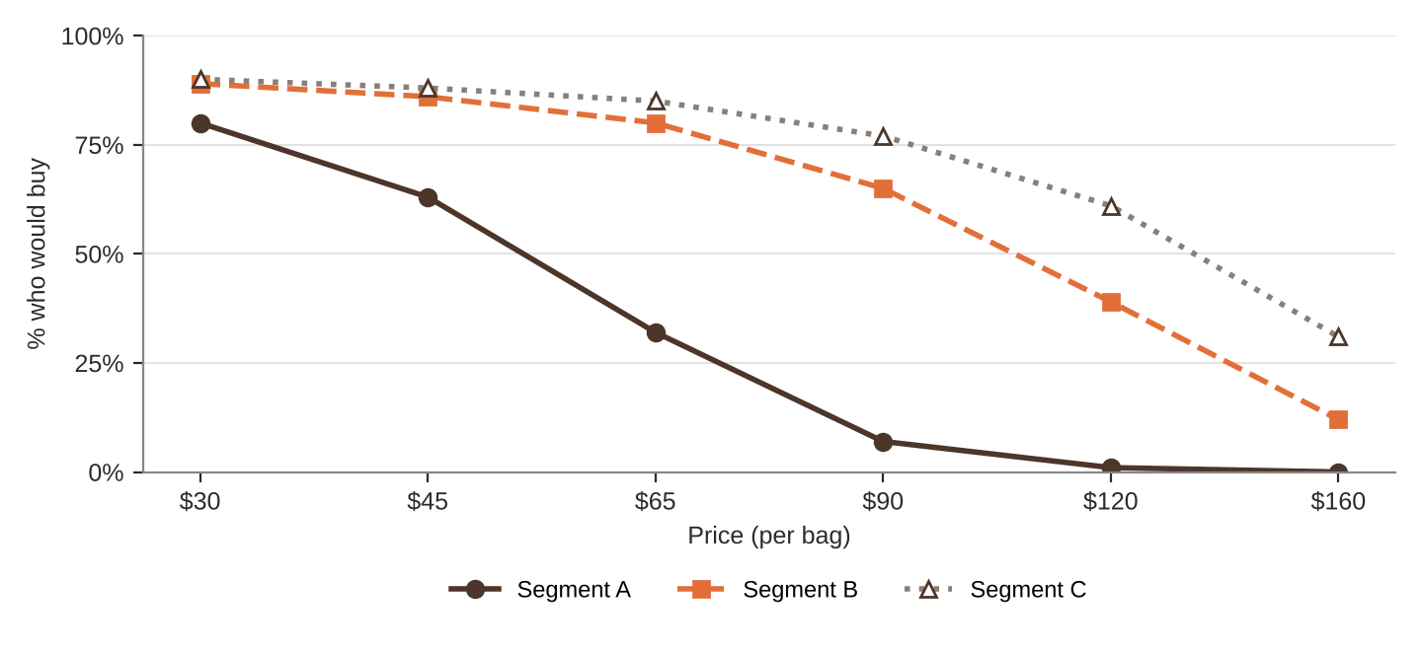
% of each segment who would buy at each price
Price | $30 | $45 | $65 | $90 | $120 | $160
Segment A | 80% | 63% | 32% | 7% | 1% | 0%
Segment B | 89% | 86% | 80% | 65% | 39% | 12%
Segment C | 90% | 88% | 85% | 77% | 61% | 31%
QUICK RULES
Must-have | A feature that 60% or more of a segment requires. Leave one out and that segment's buyers are cut in half. Leave two out and they're cut in half again.
Nice-to-have | A feature that 30% to 59% of a segment requires. Each one you include adds 5% to Fit.
Under 30% | That segment doesn't care. It adds cost and nothing else.
Fit | Start at 100%. Add 5% for each nice-to-have included. Then cut in half for each must-have left out.
Buyers | Segment size × % who would buy at your price × Fit. Round to a whole number.
Profit | Buyers × (Price − Unit cost). Unit cost = base cost + cost of every feature you added.

